Photo | 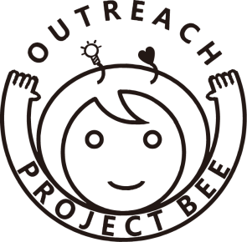  Smile Project  Application for Student
Name |  |  | Nick Name
University |  |  | Major
Religion |  |  | Sex |  |  |  | Man / Female
Facebook ID |  |  | MBTI  Myers-Briggs Type Indicator
 |  |  | Shirt size |  |  |  | Vest size
Passport No. | If you have a passport  ( Fill out Expiration date ) |  | Smoking status |  |  |  | Smoker / Nonsmoker
Contact | Mobile Phone
 | Address
 | E-mail
Specialty
Certification
Chronic disease |  | English |  | TOEFL․TOEIC․TEPS score:
 |  |  |  | Speaking Level: Fluent / Intermediate / Beginner
 |  | Second language |  |  |  | Fluent / Intermediate / Beginner
Volunteer experiences | ① Organization name: ② Period: ③ Program name:
Reason for application

I hereby certify that the above information is all true and correct.
2017. . .
Name: ( )
Pusan National University
Alliance of BEE Centers
※ Consideration on application form
1. Fill out the form. (If you can’t fill in the blank , write “None”.)
2. MBTI is most trusted and widely used for personality assessment. (http://similarminds.com/jung.html)
3. Shirt, Vest size needs to make uniform. Shirt & Vest size : S, M, L, XL
Experiences
Domestic volunteer experiences (if any)
Global volunteer experiences (if any)
Etc.

* Fill out the form after university based activities.
* Write your experiences and knowledge(technique) related in application field.
* Write in detail.

