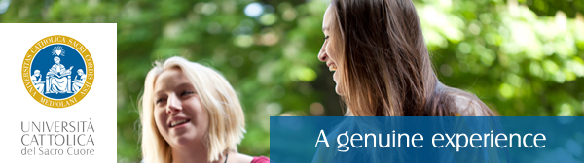
International Students
Università Cattolica del Sacro Cuore is offering to interested students or recent graduates (within one year from their graduation date) an internship position for a Junior International Student Advisor for a 6-month or 12-month period starting from September 2017.
You can find attached the internship call for applications, please note that the deadline to receive applications is June, 11 2017.
Please pass this on to any of your students or recent graduates who might be interested in this opportunity.
Should you have inquiries or need of more information please get in contact with Francesca Pasta at the following e-mail address: francesca.pasta@unicatt.it
Looking forward to receiving your students’ applications!
Very best regards,
UCSC International

