Access to the Virtual Office button, from the University of Burgos Home Page
www.ubu.es
Iniciar sesión
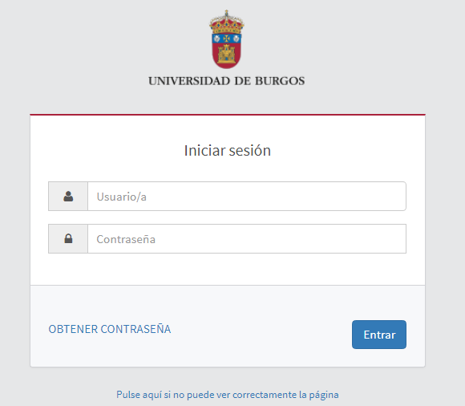

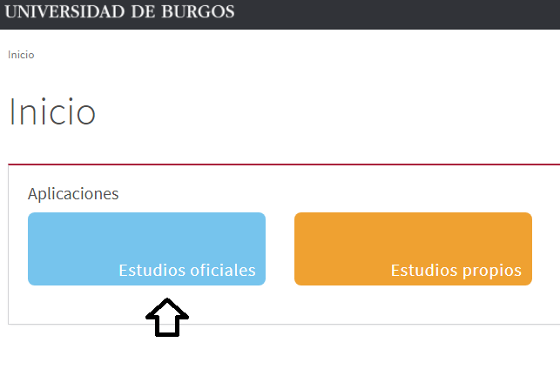

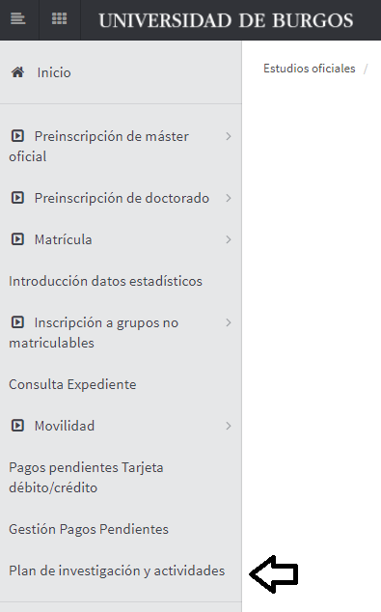

Select file. Centre 52, Doctorate
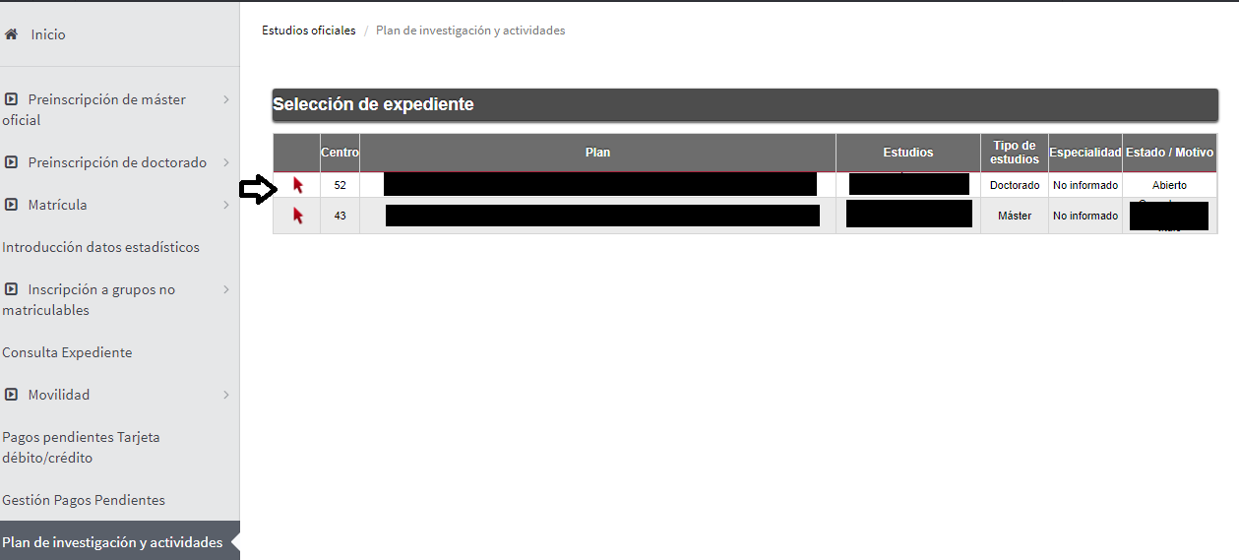

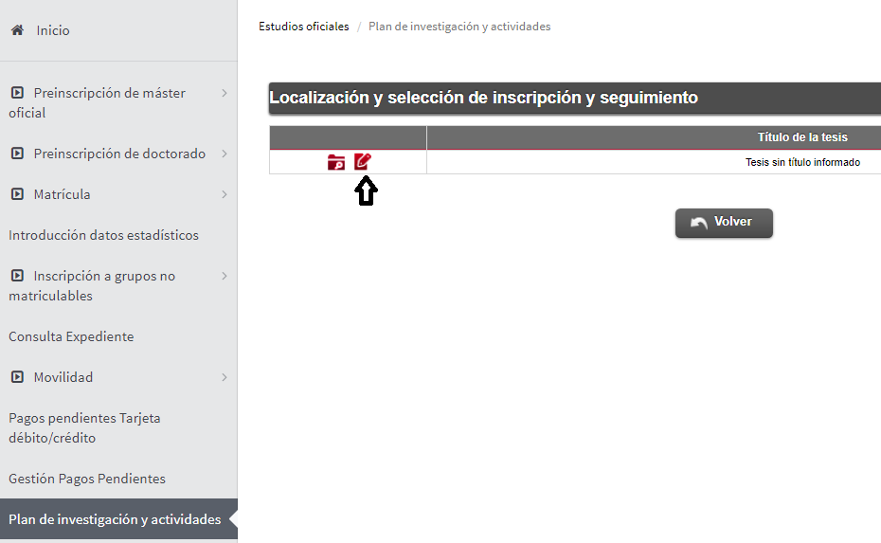

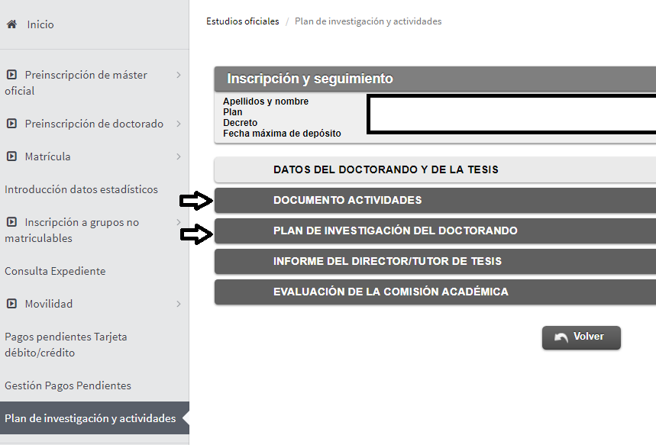
DOCUMENT OF DOCTORAND ACTIVITIES.
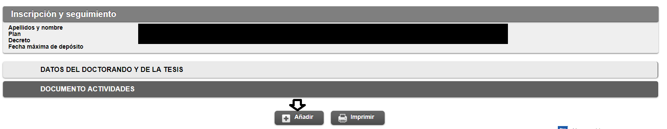
Select an activity.

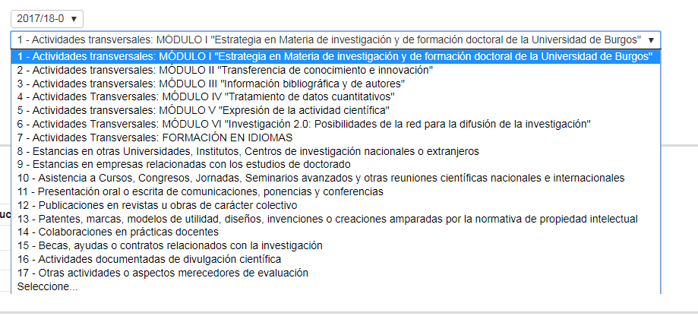
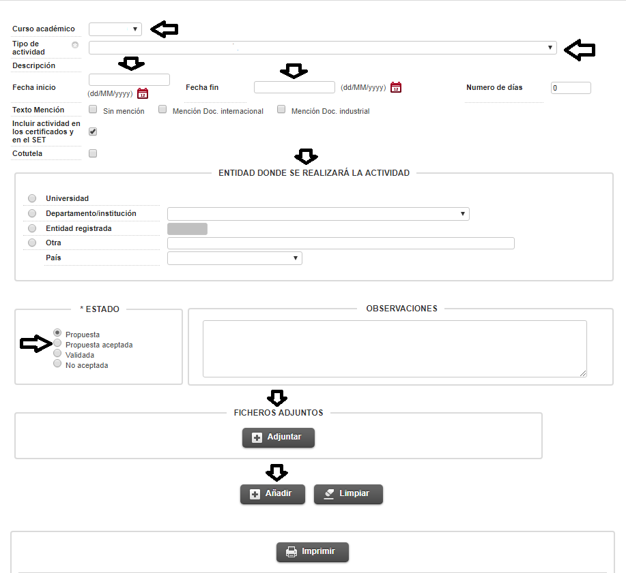

RESEARCH PLAN
Fill in the fields selected by the arrows.
In the Description, write the title of the Research Plan. The maximum file size for uploading is 10MB (12 pages)
